

Customer Shopping Behavior Analysis - Report
Prepared by
Y. Sandeep

2026

- Executive Summary
The Customer Shopping Behavior Analysis was conducted on a dataset comprising 3,900 customers, generating a total revenue of $233K. The analysis identifies strong revenue concentration within the Clothing category, which contributes 45% ($104K) of total sales. Customer purchasing behavior is significantly influenced by frequency segments, where repeat and frequent buyers demonstrate higher historical purchase volumes and long-term value contribution.

Additionally, the analysis highlights a retention opportunity, as only 27% of customers are subscribed, leaving 73% outside structured engagement programs. The largest customer segment falls under the Low-frequency category (1,147 customers), indicating a major opportunity to improve conversion into higher-value customer segments.
Overall, the findings confirm that revenue growth is both retention-driven and category-dependent. Targeted retention strategies, loyalty initiatives, and subscription expansion can significantly enhance customer lifetime value and business sustainability.
- Business Objective
The primary objectives of this customer analytics initiative are:
- To evaluate overall revenue performance and category contribution
- To analyze customer purchasing behavior across frequency segments
- To identify high-value and low-engagement customer groups
- To measure subscription adoption and retention gaps
- To support strategic marketing and revenue optimization decisions
- To provide an executive-level monitoring dashboard

- Data Overview
The dashboard is built using structured transactional customer data containing:
- Customer demographics (Gender, Subscription Status)
- Product information (Category)
- Purchase behavior (Purchase Amount, Previous Purchases)
- Customer engagement indicators (Frequency Segment)
- Review ratings and satisfaction levels
Key Metrics Derived:
- Total Customers: 3,900
- Total Revenue: $233K
- Average Purchase Amount: $59.76
- Average Review Rating: 3.8
- Subscription Rate: 27%

- Dashboard Structure
The analysis is presented across two dashboard pages:
Dashboard Page | Purpose
Page 1 – Revenue & Customer Overview | High-level revenue performance and customer metrics
Page 2 – Customer Frequency & Retention Insights | Detailed behavioral and retention analysis

- Dashboard Page 1: HR Executive Overview
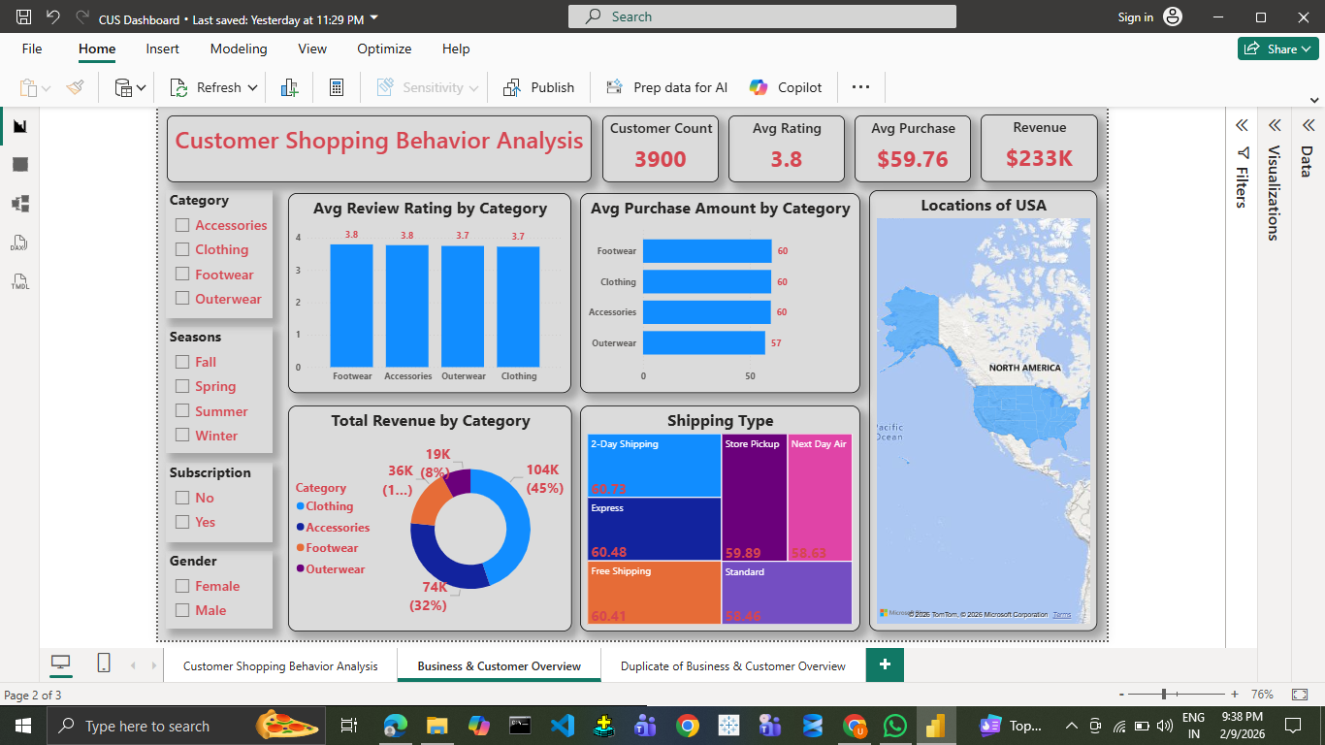
Page 1: Business & Customer Overview
This dashboard provides a comprehensive executive-level overview of overall business performance, revenue distribution, and customer metrics. It is designed to enable leadership to quickly assess revenue health, category contribution, and overall customer engagement.
The key metrics displayed include:
- Total Customers – 3,900
- Total Revenue – $233K
- Average Purchase Amount – $59.76
- Average Review Rating – 3.8

- Subscription Rate – 27%

The category-wise revenue distribution shows:
- Clothing – $104K (45%)
- Footwear – $74K (32%)
- Accessories – $36K (15%)
- Outerwear – $19K (8%)
Observation:
Clothing contributes nearly half of the total revenue, making it the dominant category.
Insight:
Revenue is highly concentrated in one category, indicating both strong demand and potential dependency risk.
Business Impact:
Strategic inventory planning and marketing investments should prioritize Clothing while simultaneously strengthening underperforming categories to reduce revenue concentration risk.
Additionally, the average purchase value of $59.76 indicates stable customer spending behavior, while the average rating of 3.8 reflects moderate-to-high customer satisfaction with room for improvement. The subscription rate of 27% highlights that a majority of customers are not yet engaged in structured retention programs.
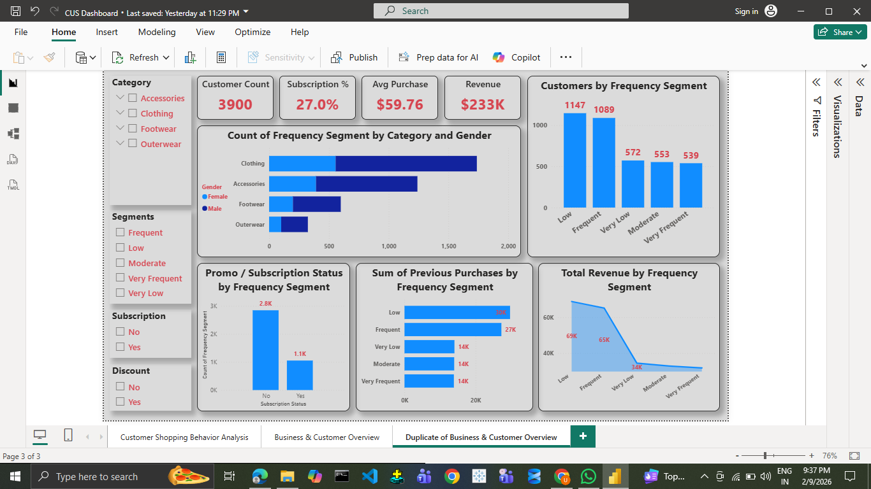
- Dashboard Page 2: Employee & Role Insights
Page 2 – Customer Frequency & Retention Insights

This dashboard focuses entirely on customer behavioral patterns and retention opportunities. It analyzes how customer frequency impacts revenue and long-term value generation.
Customer distribution by frequency segment:
- Low – 1,147 customers
- Frequent – 1,089 customers
- Very Low – 572 customers
- Moderate – 553 customers
- Very Frequent – 539 customers
Observation:
The largest customer segment falls under the Low-frequency category.
Insight:
A significant portion of the customer base purchases occasionally but has not yet transitioned into high-value repeat buyers.
Business Impact:
Converting Low-frequency customers into Frequent customers represents the largest growth opportunity for the business.

Previous purchase behavior analysis shows:
- Low – 30K previous purchases
- Frequent – 27K
- Other segments – ~14K each
Observation:
Higher frequency segments demonstrate significantly higher repeat purchasing patterns.
Insight:
Repeat purchasing behavior is predictable and structured rather than random.
Business Impact:
Retention-focused strategies such as loyalty programs, targeted promotions, and personalized marketing campaigns can significantly increase customer lifetime value.

Subscription analysis reveals:
- Subscribed Customers – ~1.1K
- Non-Subscribed Customers – ~2.8K
- Subscription Rate – 27%
Observation:
A majority of customers are non-subscribed.
Insight:
Subscription adoption remains low, indicating untapped engagement potential.
7. Key Findings
- Revenue is highly concentrated in the Clothing category
- Repeat purchasing behavior is predictable and frequency-driven
- Low-frequency customers represent the largest growth opportunity
- Subscription adoption is significantly low (27%)
- Revenue growth is retention-dependent
8. Strategic Recommendations
Based on the insights derived, the following actions are recommended:
- Implement loyalty programs targeting Low and Moderate segments
- Introduce subscription incentives and exclusive benefits
- Strengthen cross-selling between Clothing and Footwear
- Improve customer experience to increase satisfaction scores
- Monitor frequency migration (Low → Frequent → Very Frequent)
- Diversify category performance to reduce revenue dependency risk

9. Conclusion
The Customer Shopping Behavior Analysis provides a comprehensive, data-driven understanding of revenue performance, customer segmentation, and retention dynamics across 3,900 customers generating $233K in revenue. The findings reveal that revenue is heavily concentrated in the Clothing category and strongly influenced by customer frequency behavior, where repeat and frequent buyers contribute significantly to long-term value. With only 27% subscription adoption and a large proportion of customers in the Low-frequency segment, substantial growth potential exists through targeted retention strategies, loyalty programs, and subscription expansion. Overall, the analysis confirms that sustainable revenue growth is both category-dependent and retention-driven, emphasizing the importance of strategic customer engagement and continuous performance monitoring.

